25 sep 26:
- A BDEF extension itself can be extended. This is referred to as extension layering. But extension of CDS view cant have its further extension
- Assocition to parent must use $projection.<field1> = _itm.<field2>

28 sep

- Buffering is supported for CDS entities that directly select from database tables, as well as for CDS entities that select from other CDS entities.
- By exposing an association, the actual joining of the data sources is postponed until it is clear that the consumer wants to see data from the association target.
- When using an association to include a field from the association target in the element list of the current entity, a left outer join(never right) is created in the SQL statement on the database.
- For cds buffer, abap.entity.buffer needs be true, and all the underlying cds till the base tabl, need be buffer annotation/tech settings
- Nowadays rap app making is such basic, that app can be made and then enhanced step wise as per frontend performance and UX. Keep editing and keep modifying as per need.
29 sep
- You do not have to include the ETag field in ETag dependent entities. Via the association to the ETag master entity, it is ensured that the ETag field can always be reached.
- Note all the errors and their fixes : eclipse
- must know the manual actions in adt without depending on the auto complete because its unreliable or not always available
- Start with basic rap app, and enhance it as you go
- error: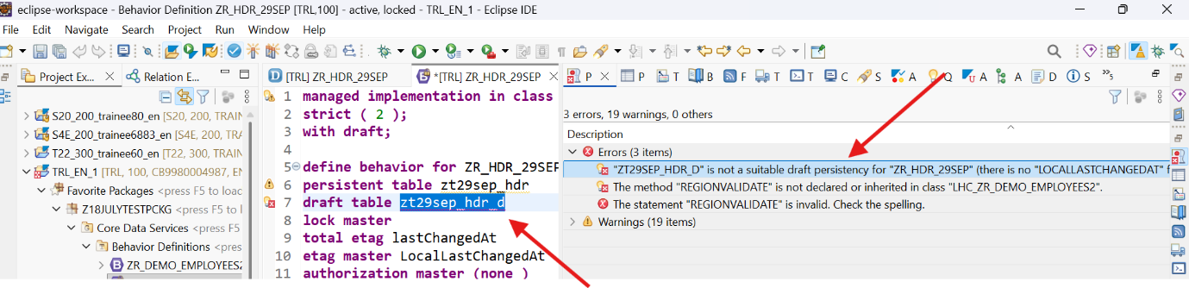
- reason: if the draft table fields and cds table aliases are different, then error happens. Hence draft table fields and cds view field names/aliases must be same.
- Whereas the general business object defines all available entities and elements, the Business Object Projection defines those entities and elements that are used for a specific service, in our case a service that is exposed for UI consumption. Link : https://help.sap.com/docs/abap-cloud/abap-rap/projecting-data-model-in-cds-projection-views
- Projection behavior definitions do not have a behavior implementation. The complete behavior is realized by mapping it to the underlying behavior. https://help.sap.com/docs/abap-cloud/abap-rap/projection-behavior-definition
- To obtain a RAP projection business object, a projection layer must be created for some or all of the nodes of the CDS view model. Afterwards, a projection behavior definition can be created for the CDS root projection view. https://help.sap.com/doc/abapdocu_latest_index_htm/LATEST/en-US/ABENBDL_PROJECTION_BO.html The projection behavior definition provides the behavior for the projection CDS view. All characteristics and operations that you want to include in the BO projection must be listed explicitly.
- CDS buffer test https://help.sap.com/docs/abap-cloud/abap-data-models/testing-cds-entity-buffers
- error: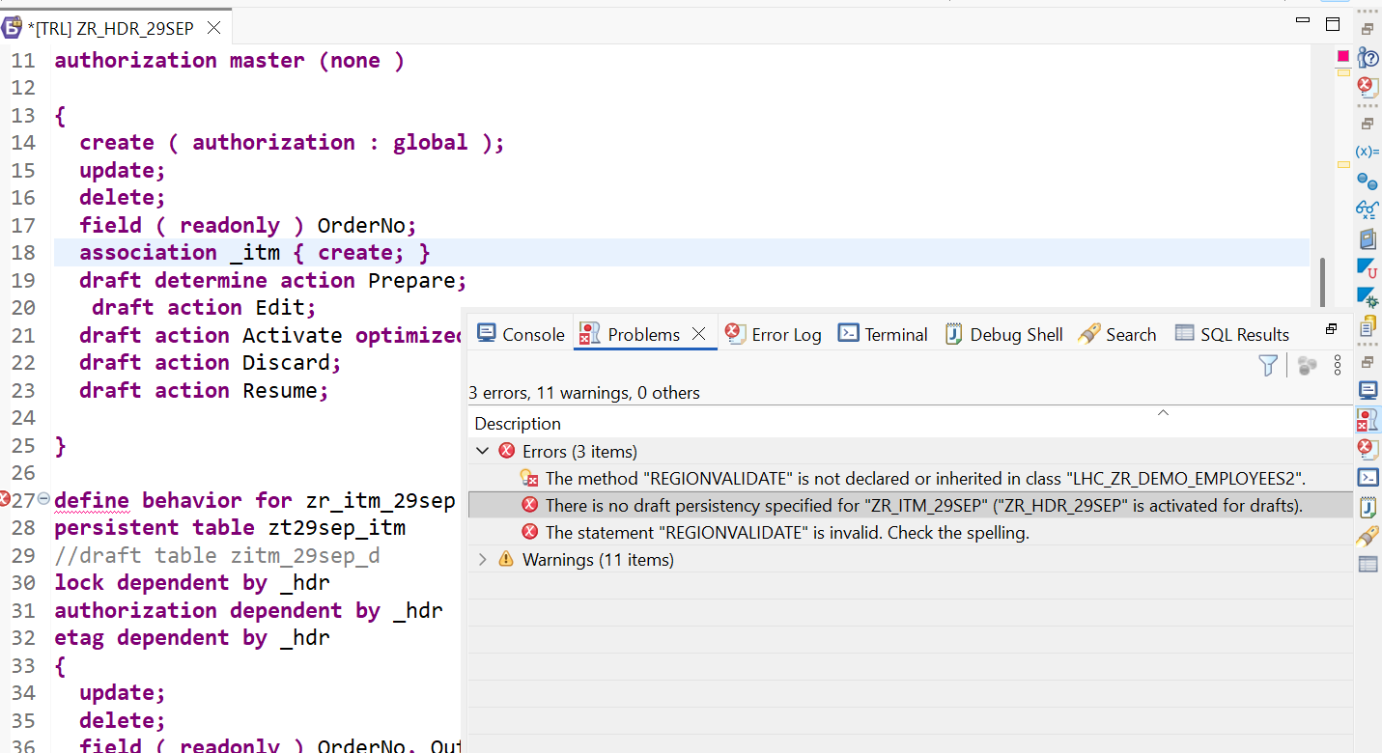reason: header table has draft, "with draft" mentioned, but item table doesnt define it
- Error: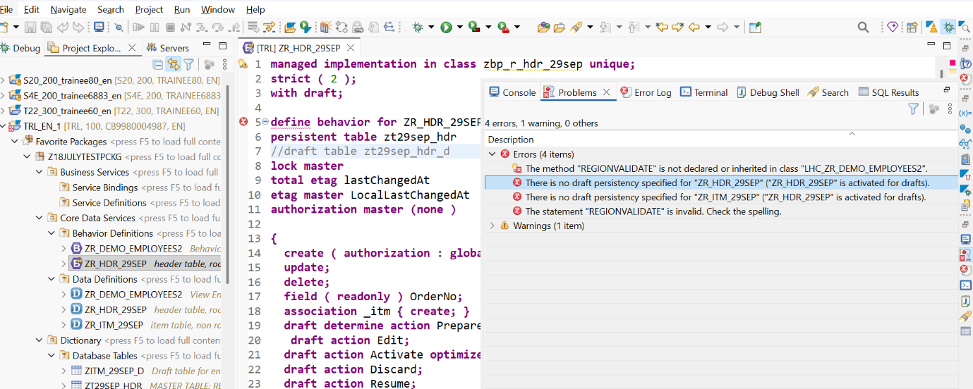
Reason: "with draft" mentioned, but drafting not defined
- WITHOUT DRAFT 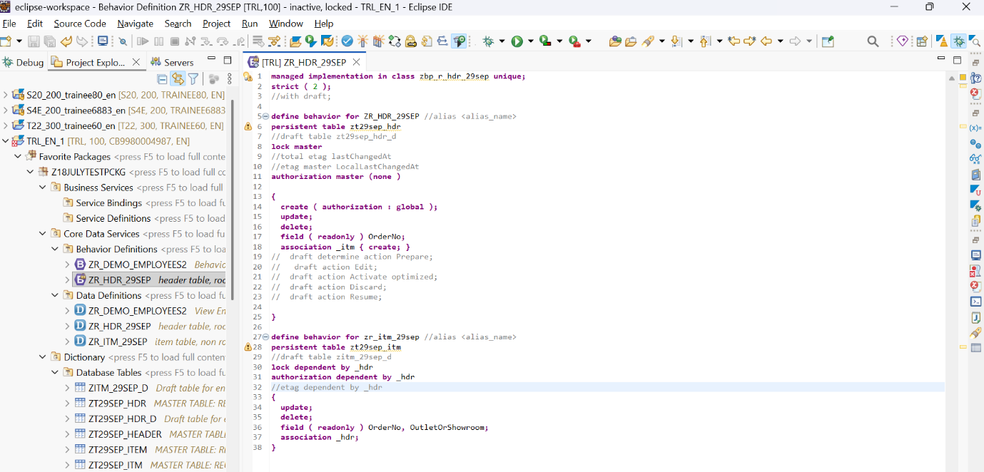
- WITH DRAFT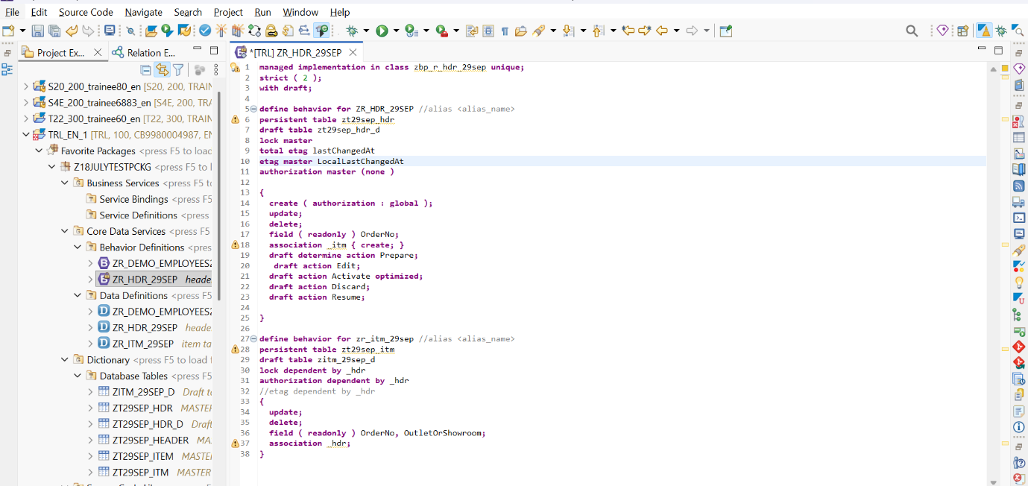
- Draft strictly depends on etag 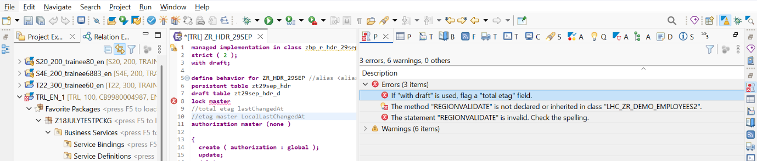
- The exclusive draft goes hand in hand with the exclusive lock. As soon as a user starts working on a draft, the system sets an exclusive lock. It is locked for other users. The exclusiveness is maintained for a defined period of time. After that period, the draft goes into an optimistic lock phase. In this phase, the draft can either be resumed by the same user or discarded, if other users take over the exclusive draft handling https://help.sap.com/docs/abap-cloud/abap-rap/exclusive-draft
- Either the draft-indicating syntax element with draft(exclusive draft) or with collaborative draft(collaborative draft) is added at the top of the behavior definition as it does not belong to a certain entity of the BO, but concerns the whole BO.
- Although draft database tables are usual ABAP Dictionary database tables and there are no technical access restrictions, it is not allowed to directly access the draft database table via SQL, neither with reading access nor writing access. The access to the draft database table must always be done via EML, with which the draft metadata get updated automatically.
- If user 1 opened a bo instance and created an entry in draft table, then user 2 wont be able to generate in draft table and would get blocked. After a cooling period, user 2 can try and end up getting user 1 ka instance deleted in draft table. And create his own entry in the draft table. In such case how is draft compares the etag field? because user 1 and use 2 ka draft get compared with persistance table ka etag field and when found same only that is persisted
- https://learning.sap.com/courses/building-transactional-apps-with-the-abap-restful-application-programming-model/understanding-the-draft-concept DRAFT
- While creation of projection layer(cds , bdef, sd, sb), this error came 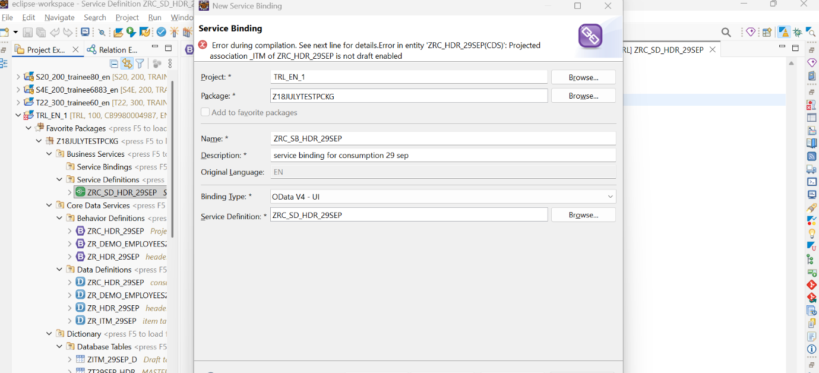reason: this happens because "redirection" is missing in the projection layer of the item header arrangement in CDS views. child projection view wasnt created at all
- https://github.com/SAP-samples/abap-cheat-sheets.git
- error: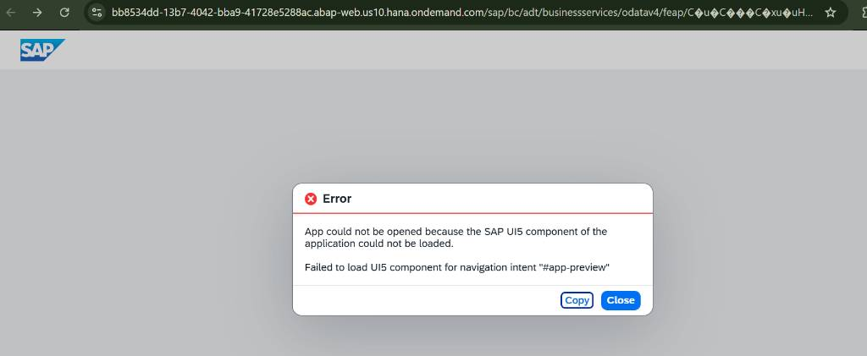RCA: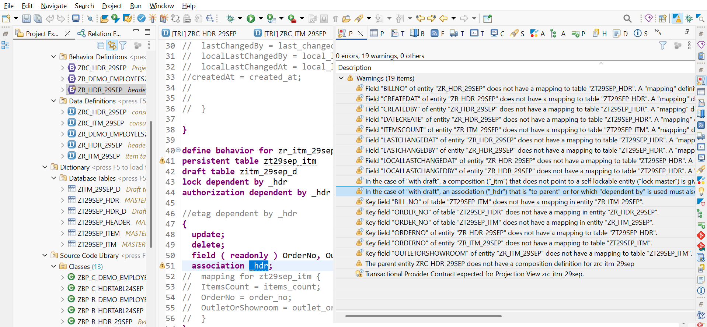
solution: resolved by adding {with draft} in the association keyword

30 sep 26
- total etag is available for draft-enabled business objects only and for these, it is mandatory. It manages the transitions from active data to draft data and vice versa. https://help.sap.com/doc/abapdocu_816_index_htm/8.16/en-US/ABENBDL_ETAG.html : "total etag" used only with "with draft". This means, "without draft" would use etag master + etag master (parent child each) OR etag master + etag dependent (parent child) . "With draft" would use, additionally, total etag.

- As soon as you draft-enable a business object by adding with draft to the behavior definition, all BO-internal associations are automatically draft-enabled. To make this behavior explicit, the behavior prompts you to specify the compositions within a draft BO with with draft. [https://help.sap.com/docs/abap-cloud/abap-rap/draft-enabled-associations] [https://help.sap.com/docs/abap-cloud/abap-rap/adding-draft-capabilities-to-managed-business-object]
- Draft methods : [https://help.sap.com/docs/abap-cloud/abap-rap/preparing-draft-instances-for-activation] [https://help.sap.com/docs/abap-cloud/abap-rap/adding-draft-capabilities-to-managed-business-object] Use the Activate action in its optimized variant to increase the performance by skipping determination and validation executions that are not required.
- Determination and Validation Modelling: its in itself a concept, teaches how to do it
- If an entity is an ETag master entity, it has its own ETag field.[ https://help.sap.com/doc/abapdocu_816_index_htm/8.16/en-US/ABENBDL_ETAG.html]
- The ETag master field MasterField must be annotated in CDS with the annotation @Semantics.systemDateTime.localInstanceLastChangedAt: true [https://help.sap.com/doc/abapdocu_816_index_htm/8.16/en-US/ABENBDL_ETAG.html] etag master uses locallastchangedat/by
- The field TotalEtagField must be annotated in CDS with the annotation @Semantics.systemDateTime.lastChangedAt: true [https://help.sap.com/doc/abapdocu_816_index_htm/8.16/en-US/ABENBDL_ETAG.html]: total etag uses lastchangedat/by
- The LocalLastChangedAt acts as the local OData ETag, while LastChangedAt acts as the Total/Draft ETag to protect active data after lock expiration. Etag is entity tag.

1 oct :
- AMDP table function have 2 flavors : for AMDP methods, and, for CDS table functions [https://help.sap.com/doc/abapdocu_816_index_htm/8.16/en-US/ABENAMDP_FUNCTION_METHODS.html]
- AMDP Scalar Functions have 2 flavors : for AMDP methods, and, for CDS scalar functions [https://help.sap.com/doc/abapdocu_816_index_htm/8.16/en-US/ABENAMDP_FUNCTION_METHODS.html]
- An AMDP function implementation for an AMDP scalar function can be called in ABAP programs like a regular functional method. An AMDP function implementation for an AMDP table function, on the other hand, is generally used to implement a CDS table function. It can be used as a data source of ABAP SQL read statements using the CDS entity, but cannot be called in ABAP programs. [https://help.sap.com/doc/abapdocu_latest_index_htm/latest/en-us/ABENAMDP_FUNCTION_METHOD_GLOSRY.html]
- https://developers.sap.com/#featured/sap-btp-cockpit : Catalogue of all SAP products
- https://community.sap.com/t5/technology-blog-posts-by-members/locking-in-s4hana-via-the-durable-locks-cds-view-objectmodel-lifecycle/ba-p/13412190
- Learn which object/feature is supported where: interface? Projection? Etc.

Best Regards
Sachin

